Kovvuri sai vamsi reddy

# Assignment AWS essentials

Assignment-1

Create AWS account:- First of all we need to create a free AWS account for that we need to search for aws website and make sure to create a account.

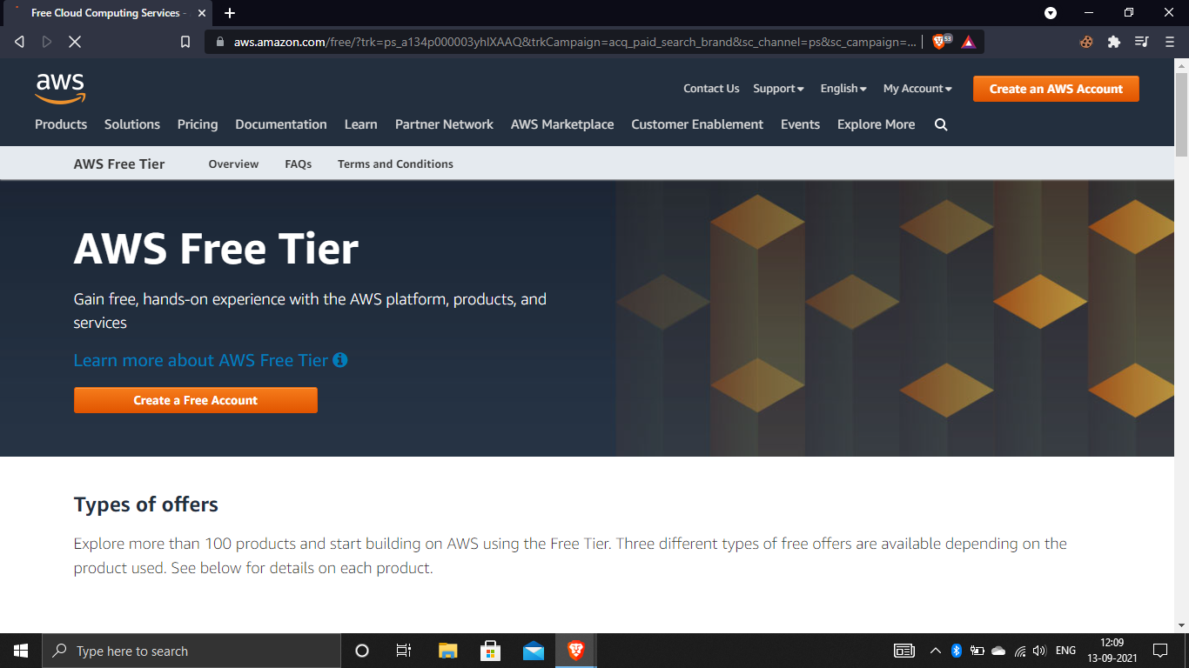

After completing creation of your account we will be notified like this. In that you need to go to the “Sign in to the console”.

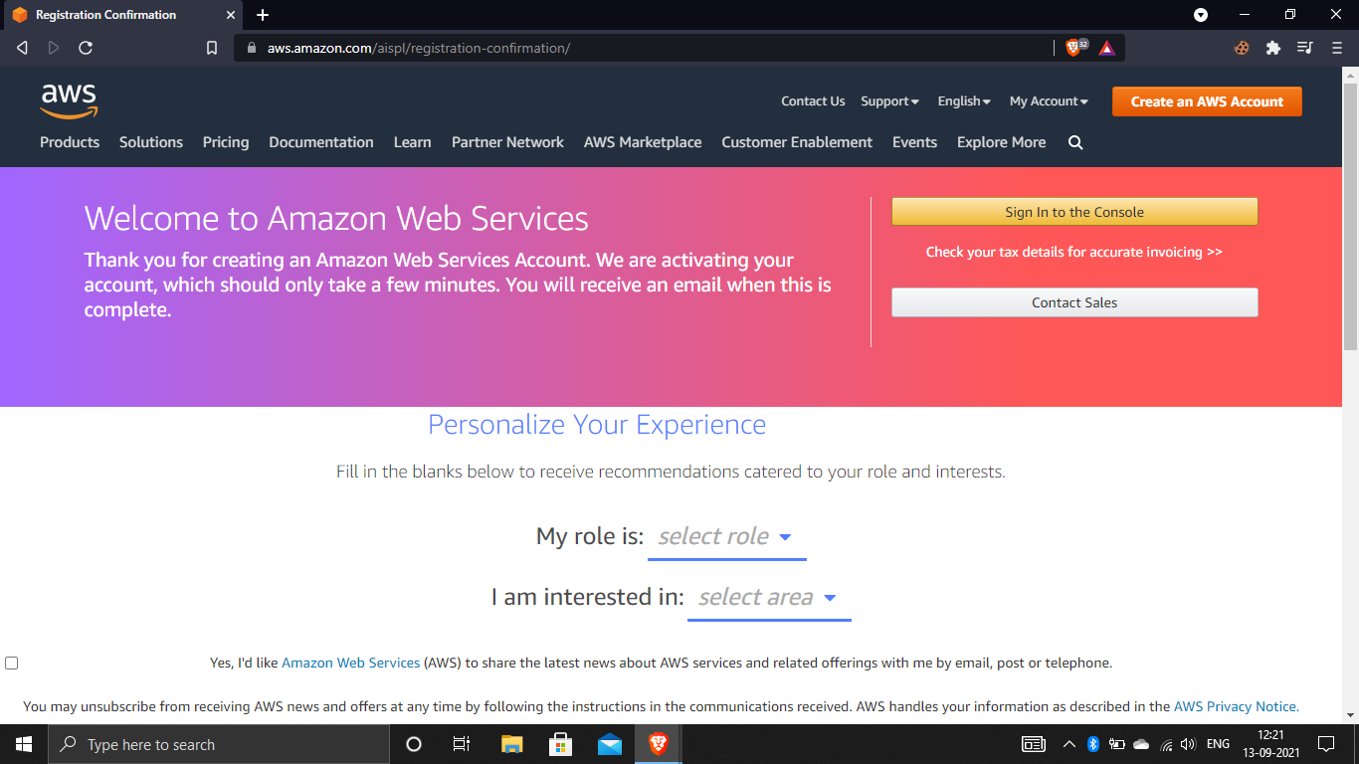

Now login as root user using your email and password which you have created on AWS.

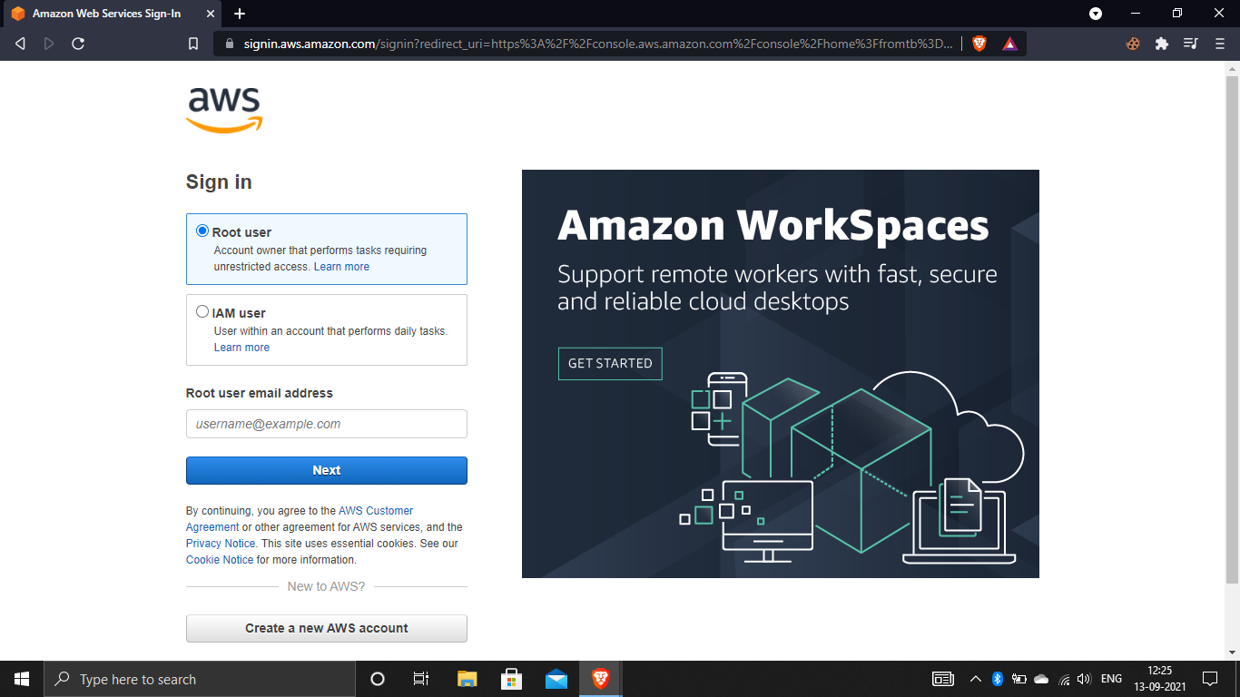

After completing login when your account is active you will be go to AWS Management

Console and here you will see all the services.

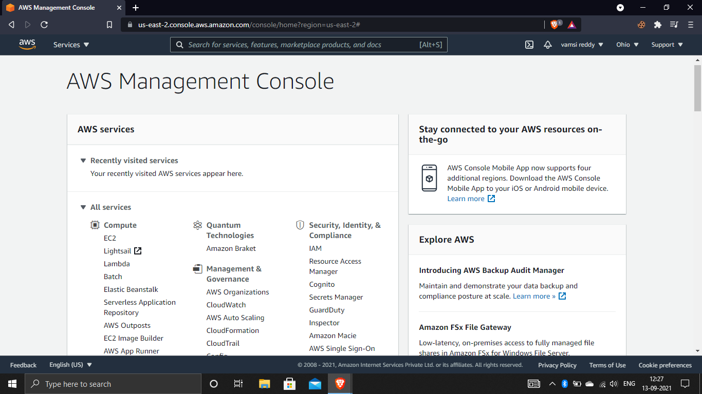

Working with IAM:-

Create an IAM user:-

In this you need to search for IAM in search bar.

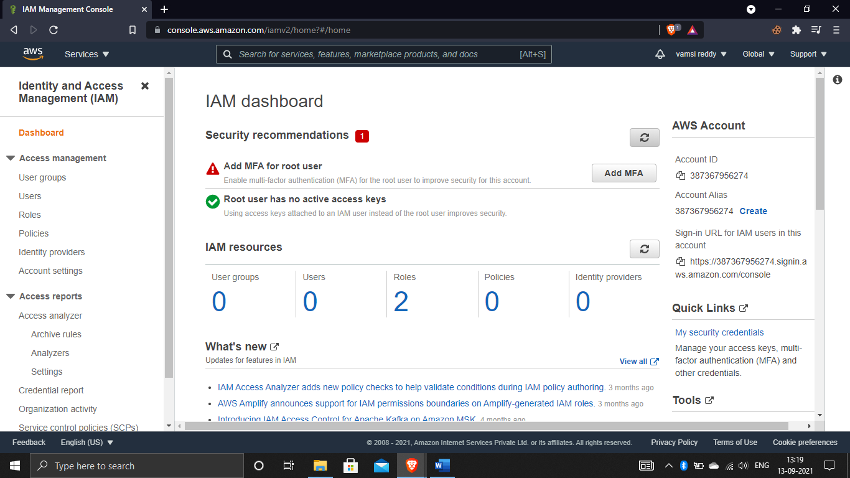

Now click on users you see like this. and at right corner you see add users click on that

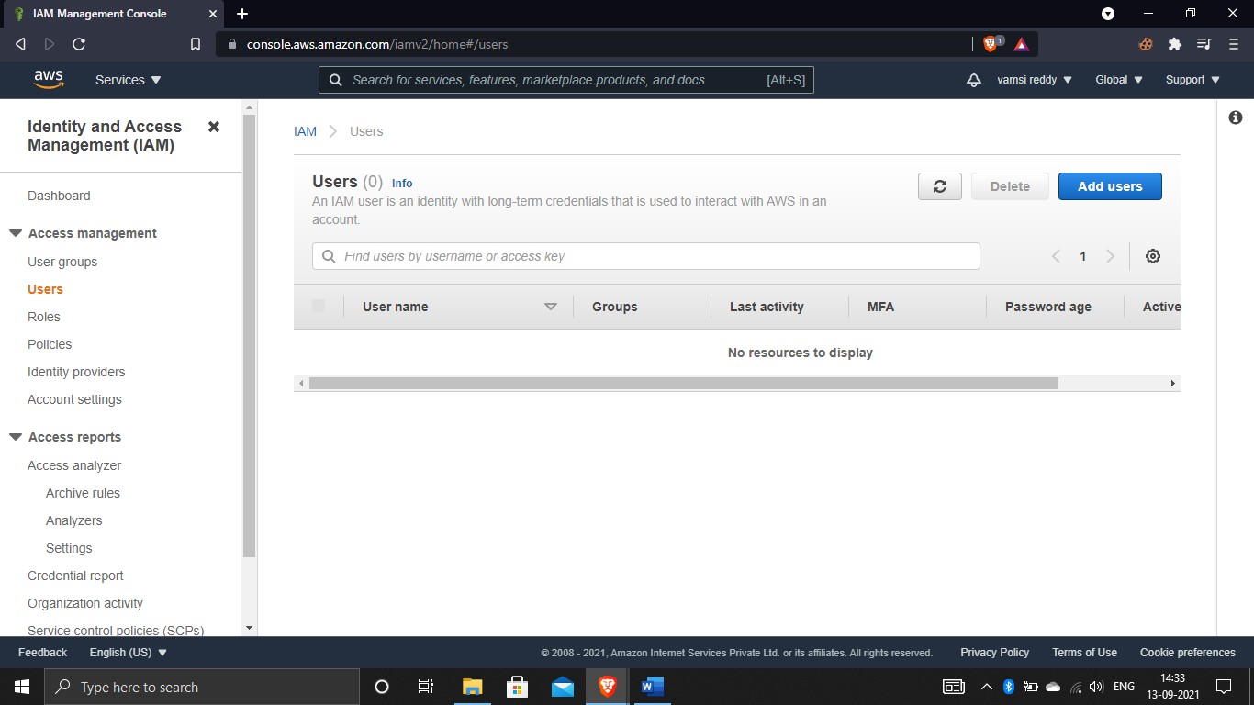

After that give some random name which is a unique user name, And next give the permissions whatever you want to give to user. After that it asks you to give console password which is autogenerated passwords or custom passwords. After completing the process it shows you a message of required password reset its optional that means if u enable the option the user may change the password when he login for first time.

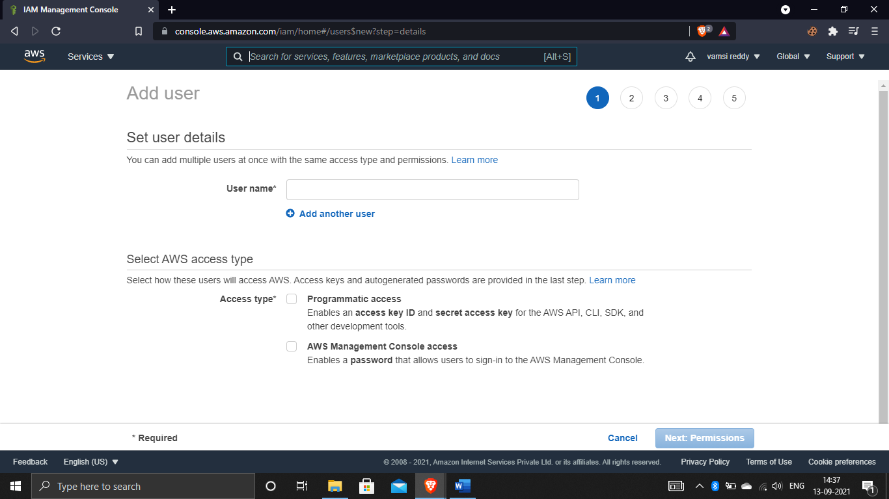

Attach a AWS managed policy (S3 full access):-

Now you need to give some more permissions to the users. They are 3 options in this following image. You need to give permissions by groups, copying permissions above the user or you need to give it by your own permissions like S3 full access permission. after completion click on next tags.

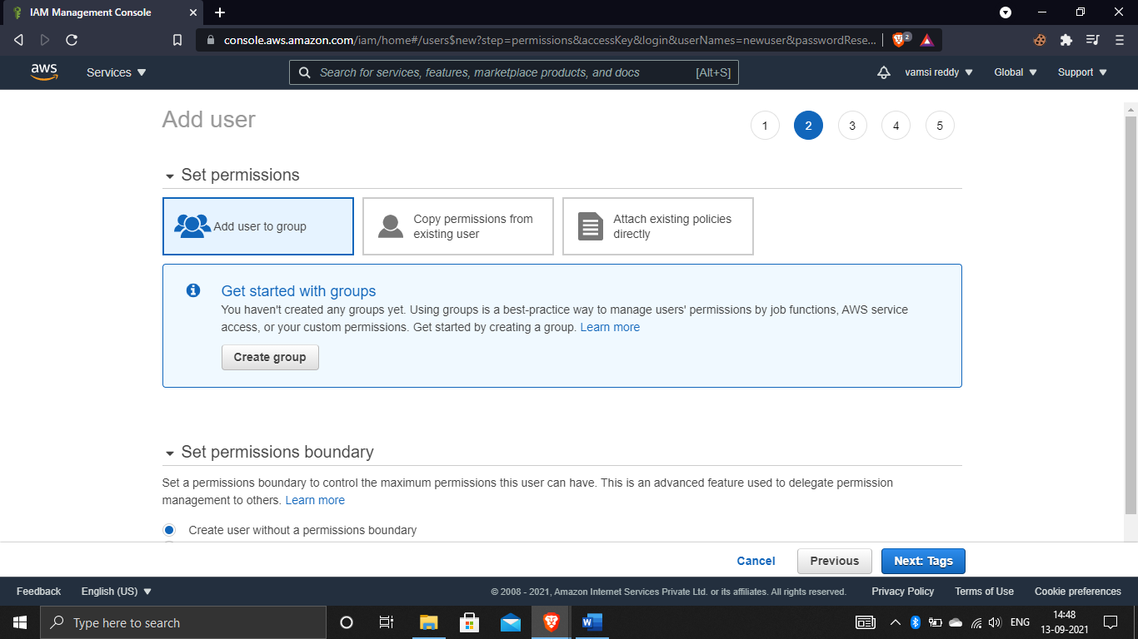

Now you will go to tags, next you see an option called review click on that now check whether all the permissions you have granted.

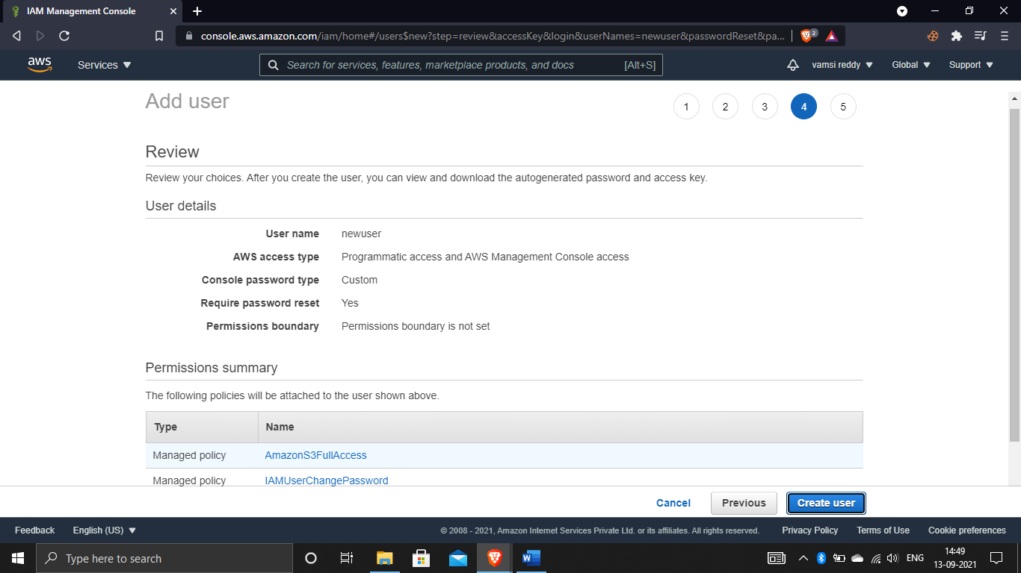

After completion you need to click on create user.

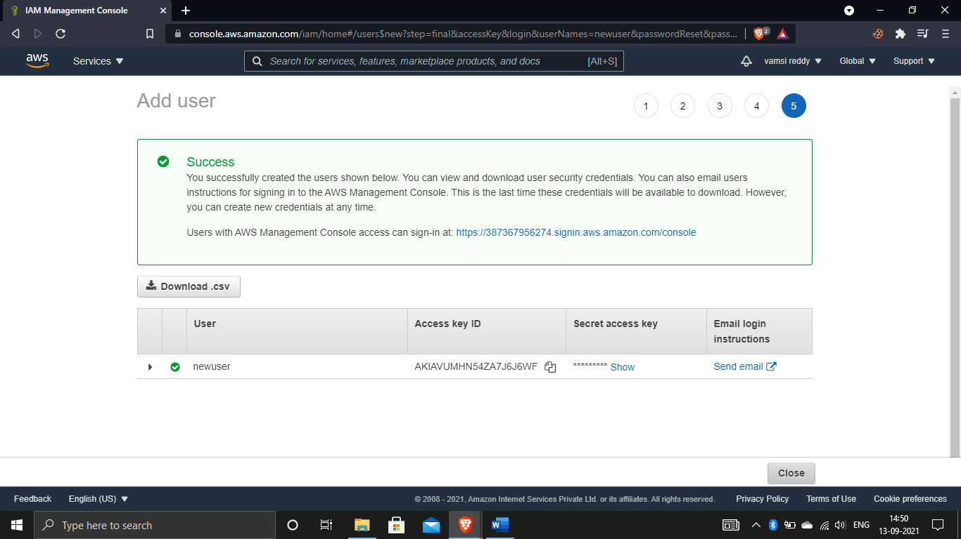

Download the .csv file, And finally the user has been created.now go to the user and copy the 12 digit words for login.

Login as IAM user and and show that policy is applied.(S3,EC2,IAM):-

Now login as IAM user with 12 digit number and click on next.

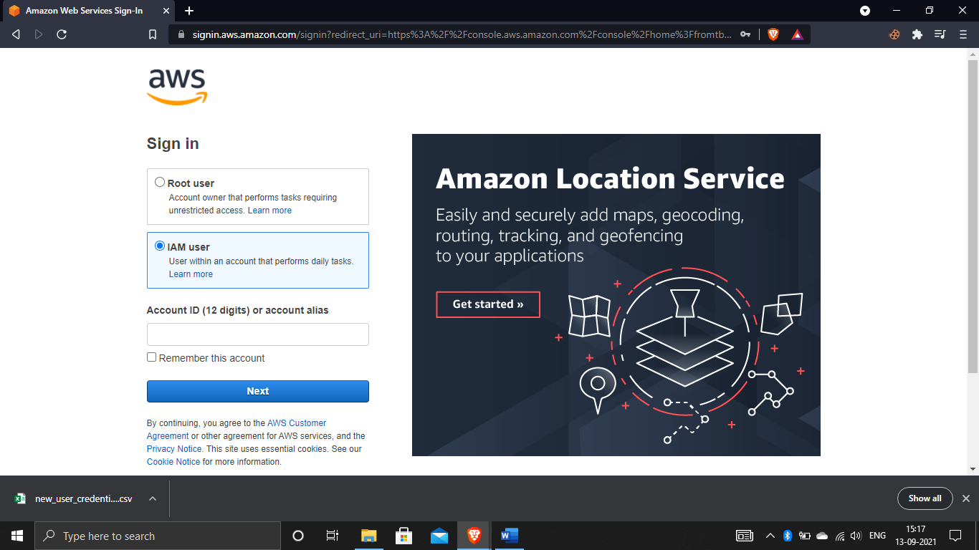

When it going to login its shows like this, after giving the IAM user name and password click on signin.

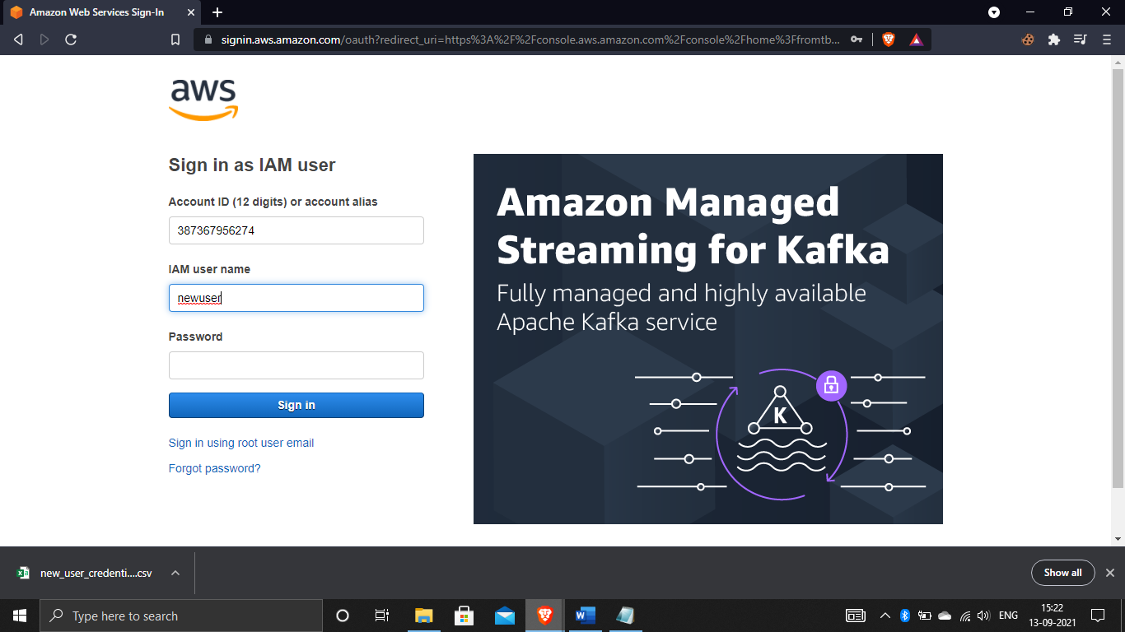

After that it shows to change the password when we enabled the option while creating the user ,now use your old password and give new password and confirm it and click on “confirm password change”.

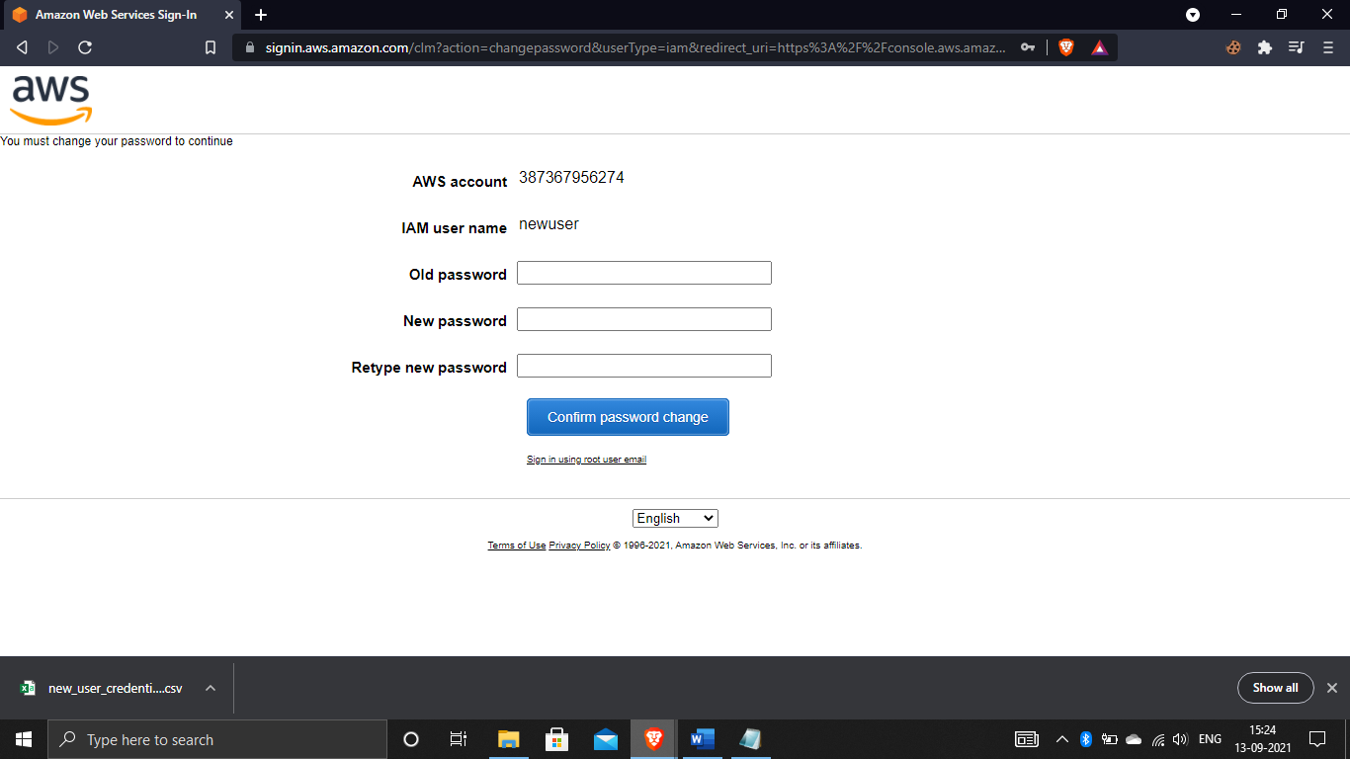

And finally you have successfully login as newuser.

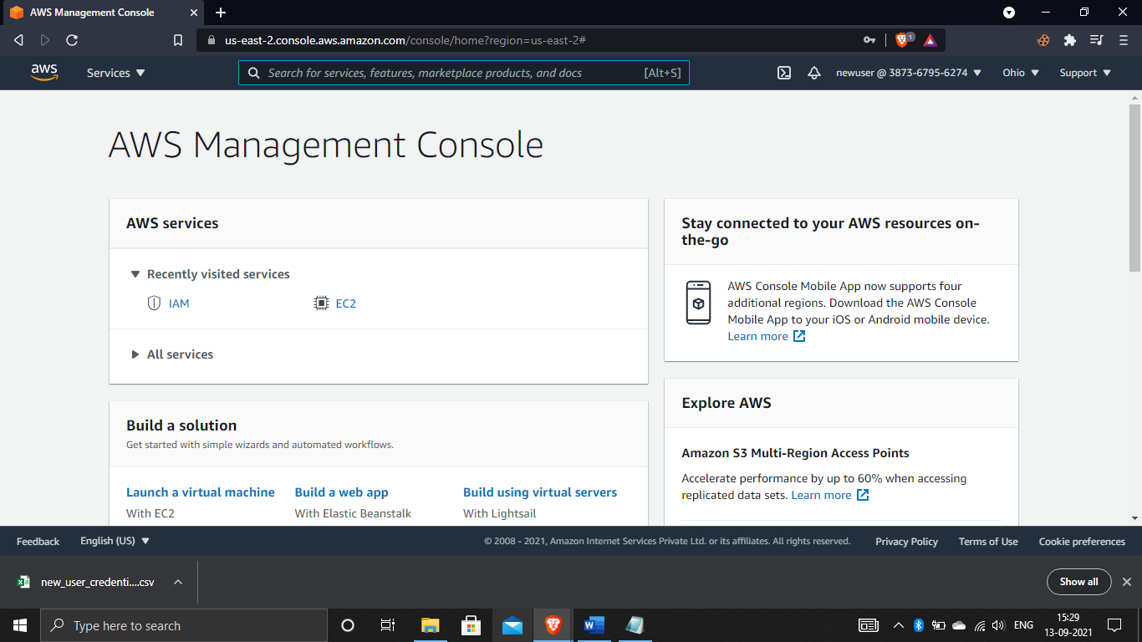

Now search for S3 in S3 dashboard whether it is accessing or not in this we have access to create buckets.

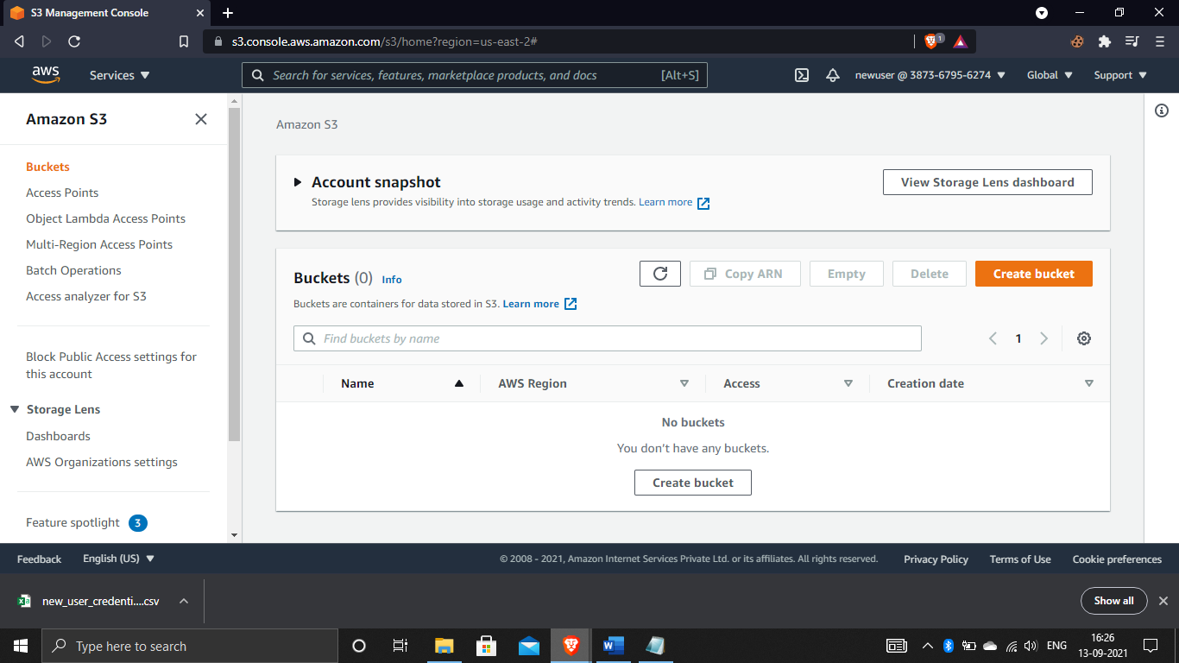

Now we check whether EC2 is access for the user. here we got API error which means the user only have full permissions S3 not in EC2.

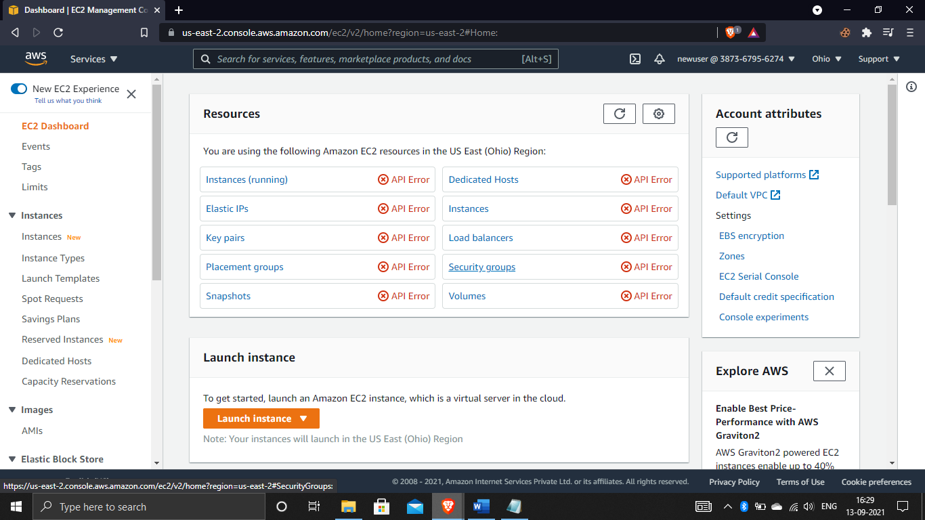

Now check whether the IAM permissions are accessing for user,here the user doesn’t have IAM permissions which means the user has only access in S3.the permissions are decided by the root which the user has access.

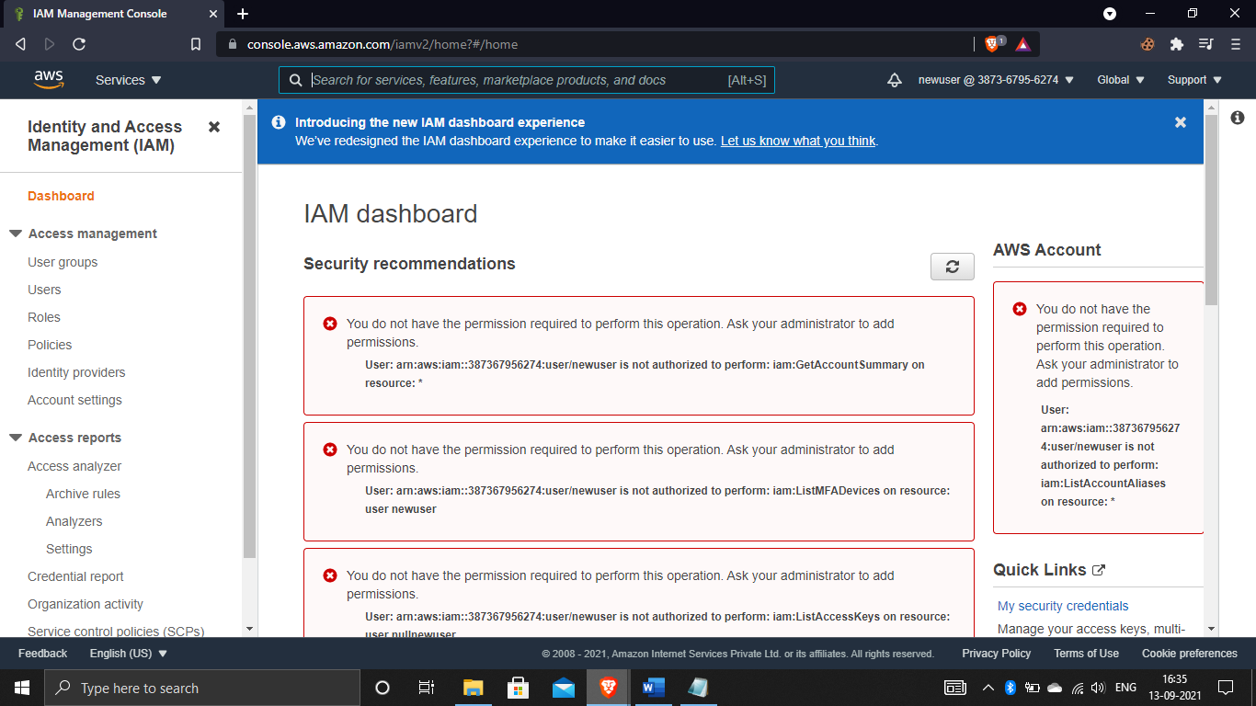

# ASSIGNMENT-2

Working with EC2 instances:-

Create a EC2 instance:-

First of all we need to login to root account and then search for EC2 in that dashboard click on instances to create EC2 instances.to create new one click one launch instances.

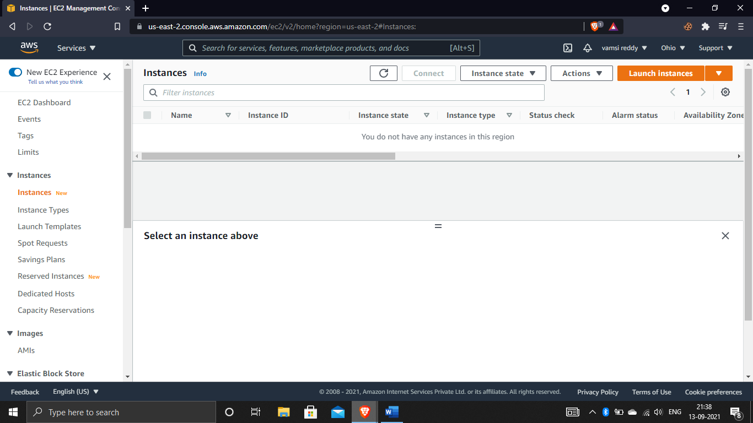

When you click on launch instances it shows choose an Amazon Machine Image(AMI) in that select free tier only to get free stuff. Now select amazon linux 2 AMI

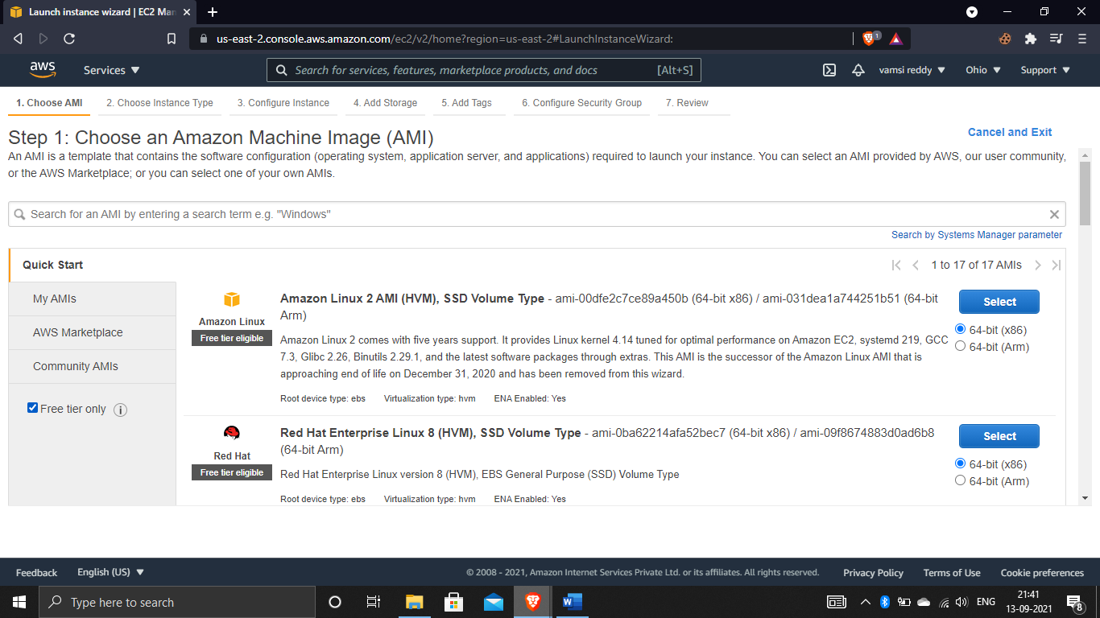

Now choose the “t2” instance from “t” family, in this t2 micro t represents the family,2 represents the generation and, micro represents the size of the instance. Now click on next configure instance details for further information.

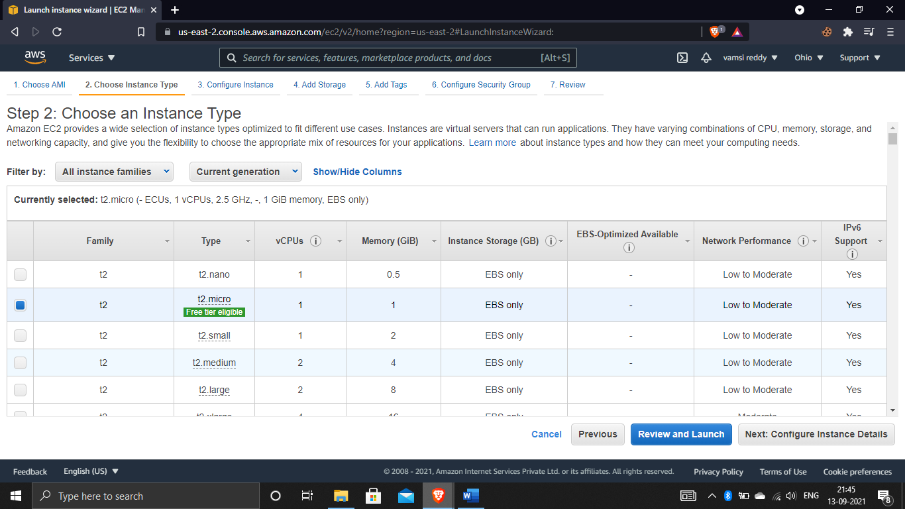

Now we need to configure instances in this we need to change some changes like shutdown behavior to terminate and enable termination protection,and click on next add storage.

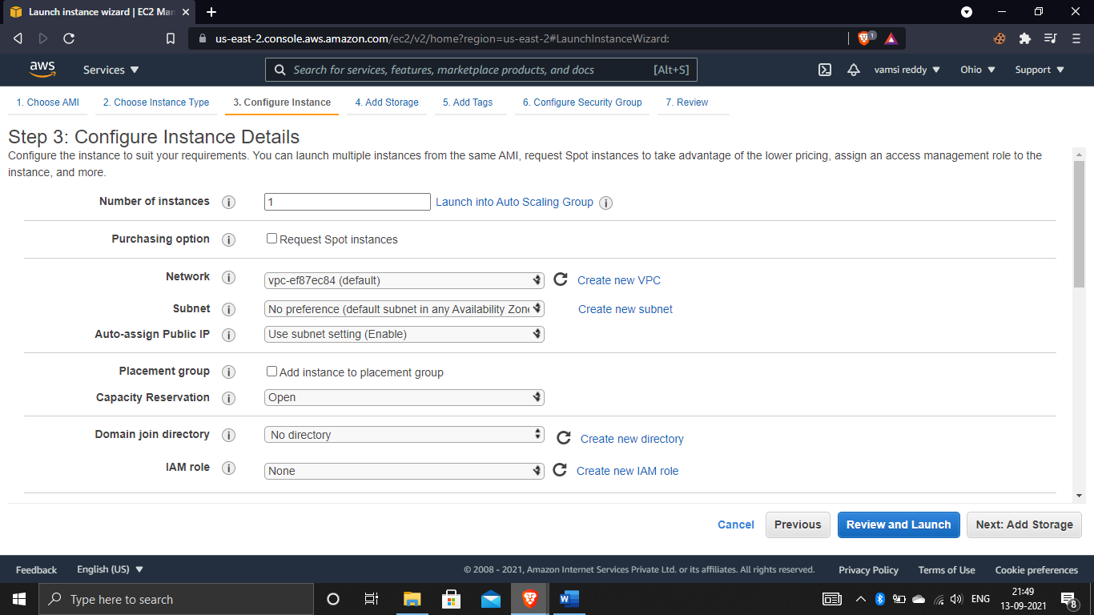

Now we see root volume which stores the operating system data in it. there are so many types of volumes. Enable the delete on termination because when you terminate the instance it will be deleted permanently from the ebs volume. Now click on add tags.

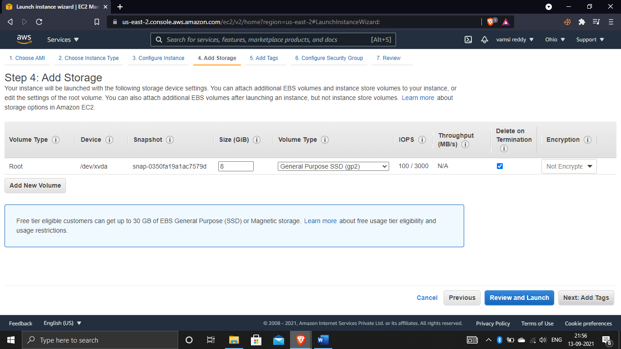

Tags are basically metadata it consists of case sensitive key value pair. For example we give a name to the value like mynewserver and don’t do any changes.and now click on configure security group.

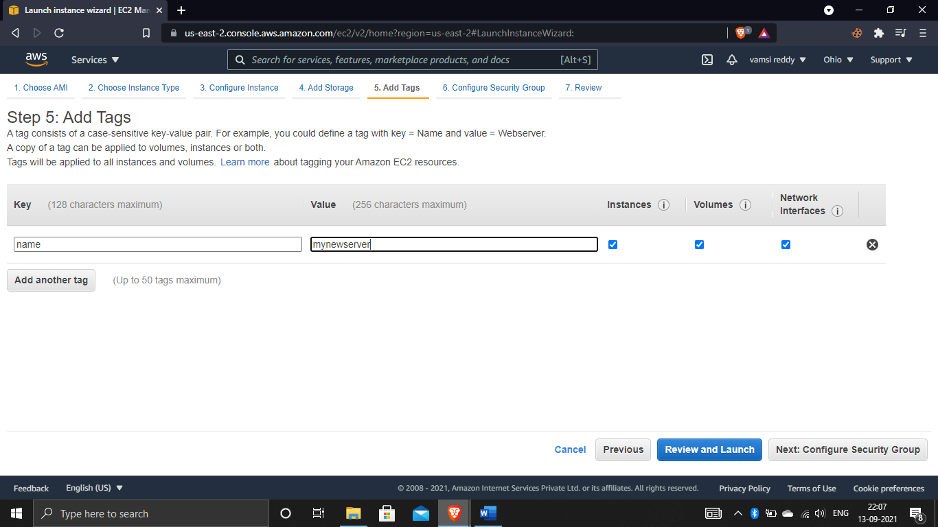

Security group is a virtual firewall it decides the traffic that can have access to the instance. give any name to the security group and select the type to All traffic, and source to anywhere.and click on review and launch.

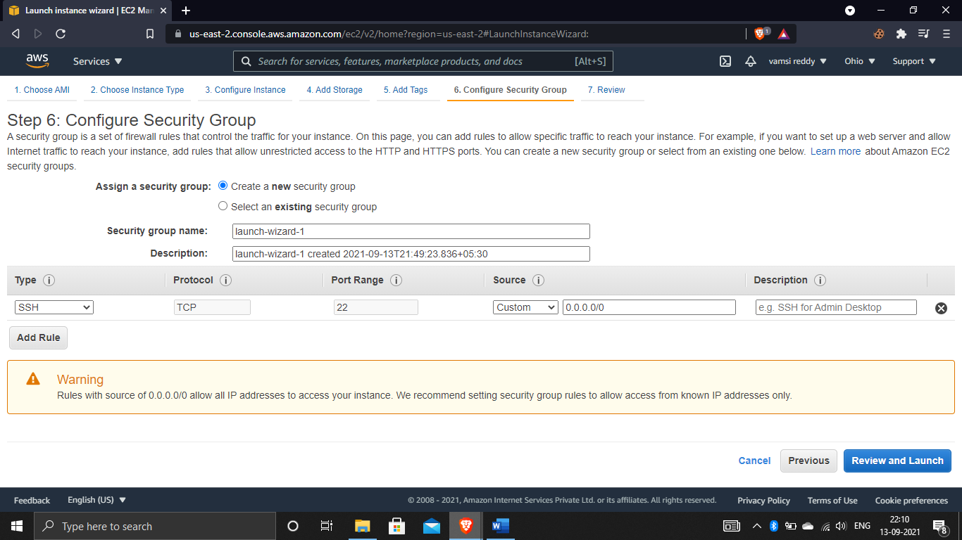

This is the place we need to review what we selected and click and launch

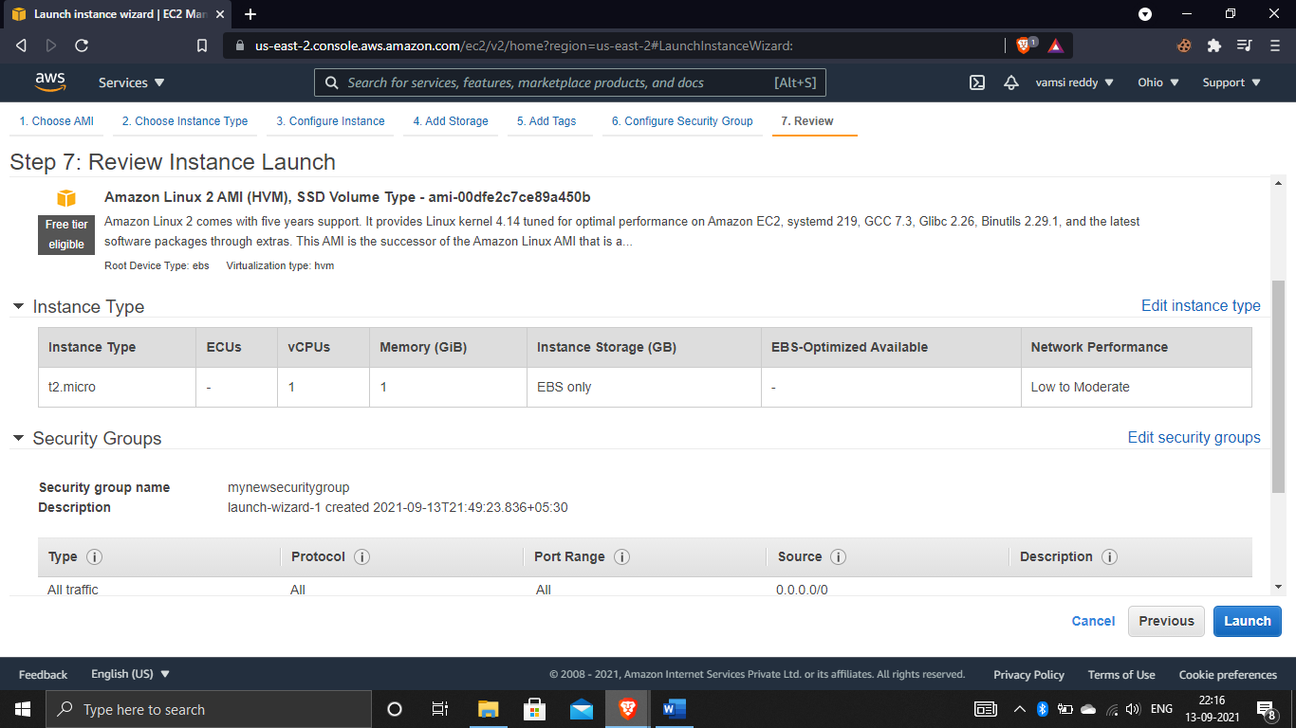

Now we need to create a keypair for that select as create a new keypair and select RSA and give some name to it after that download the keypair. And now click on launch instances.

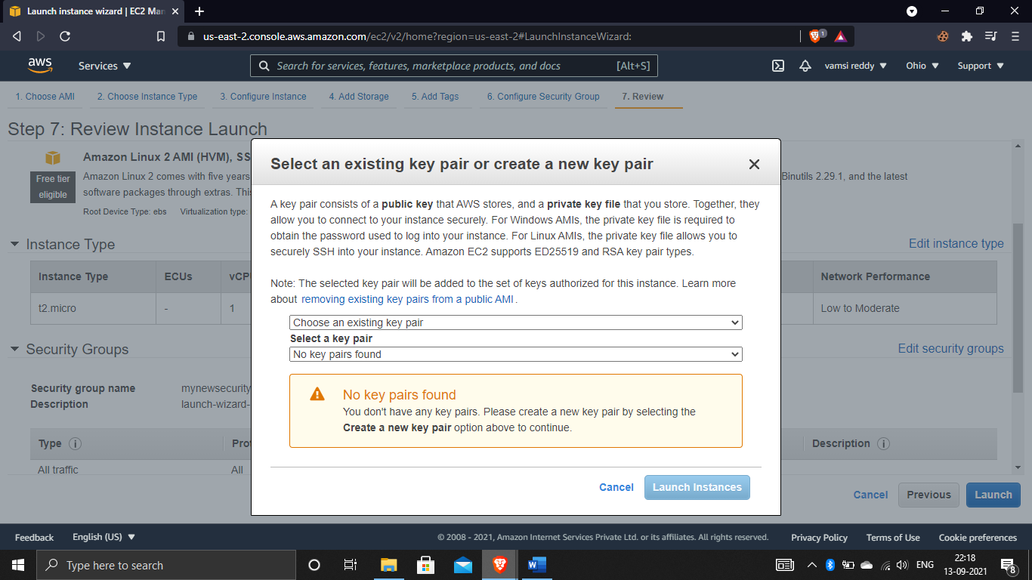

And now the instances are going to ready.

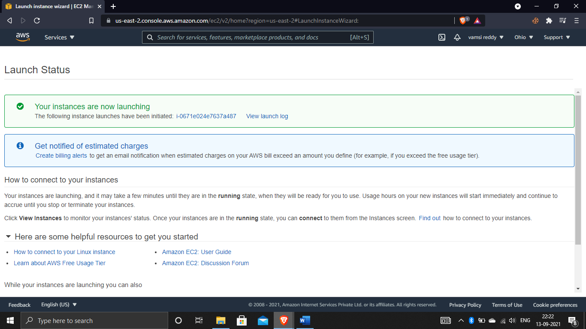

And after completion of the checks it shows completed. And finally the instance is created.

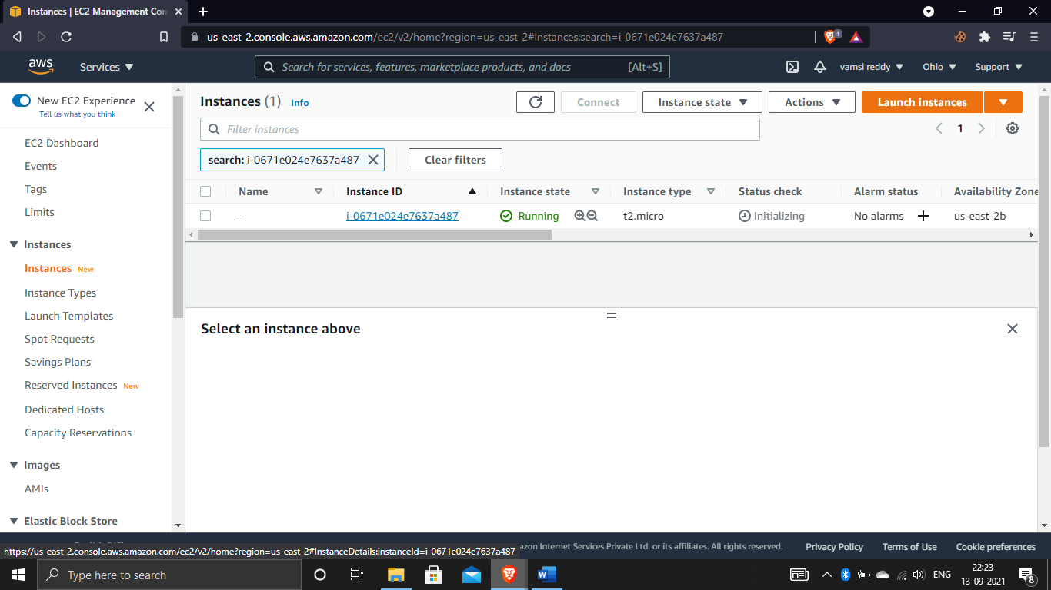

Connect to the instance:-

For connecting to the instance select the server click on connect. now you see the EC2 instance connect in this we see instance id and public ip address. And now click on connect.

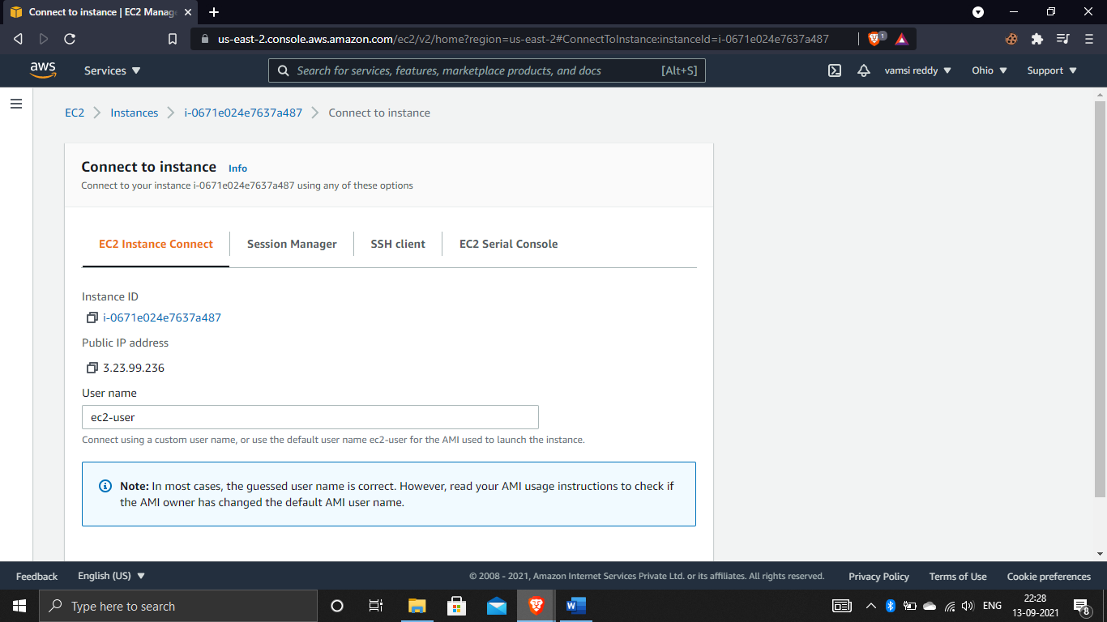

And now we see linux server we have created.

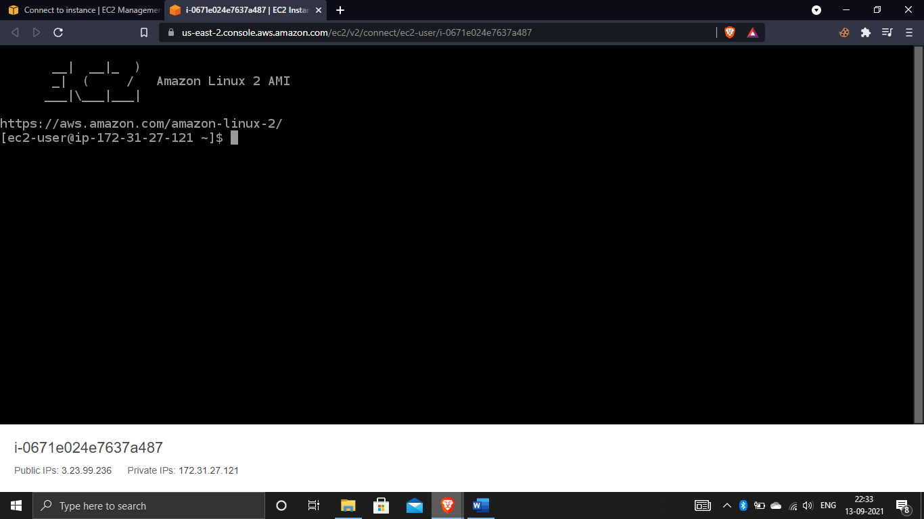

## ASSIGNMENT-3

Working with EBS volumes:-

Create an EBS volume and attach to an EC2 instance:-

To create an ebs volume we need to go to EC2 and search for the option “create volume” and select the volume and click on it

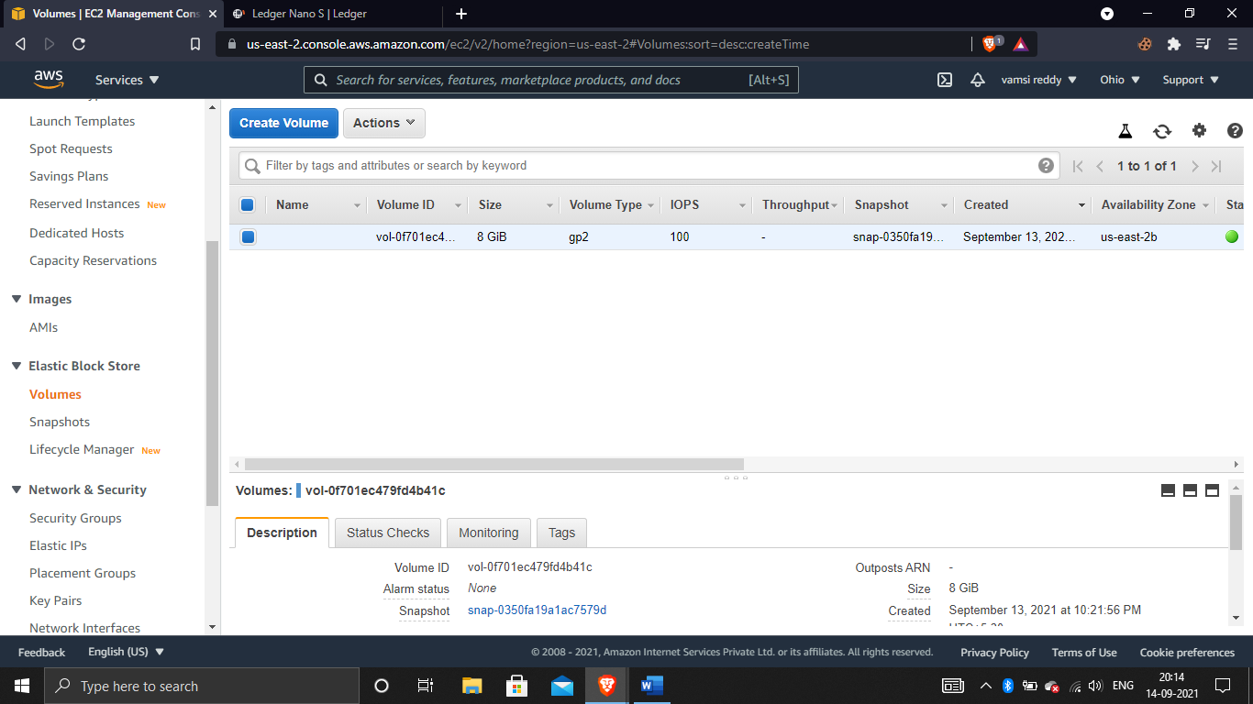

In this we have ssd and hdd.in this what volumes you are selecting is up to you and give the size of the volume and here the instance and ebs volume are same in availability zone then you will be attach the volume to it.after that if you create a separate volume you need to give snapshot id . now click on create volume to create it.

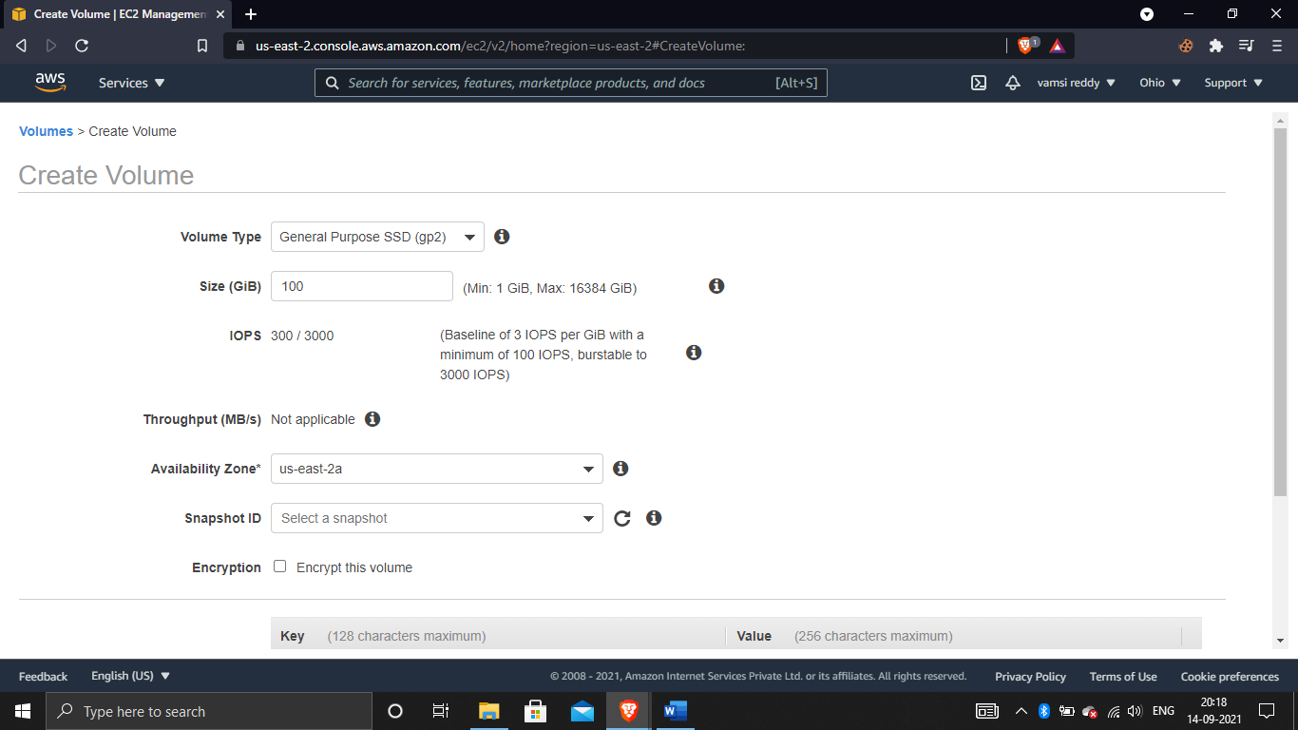

Now check whether the volume is available or not if it is available select the volume and click on actions to attach the volumes.

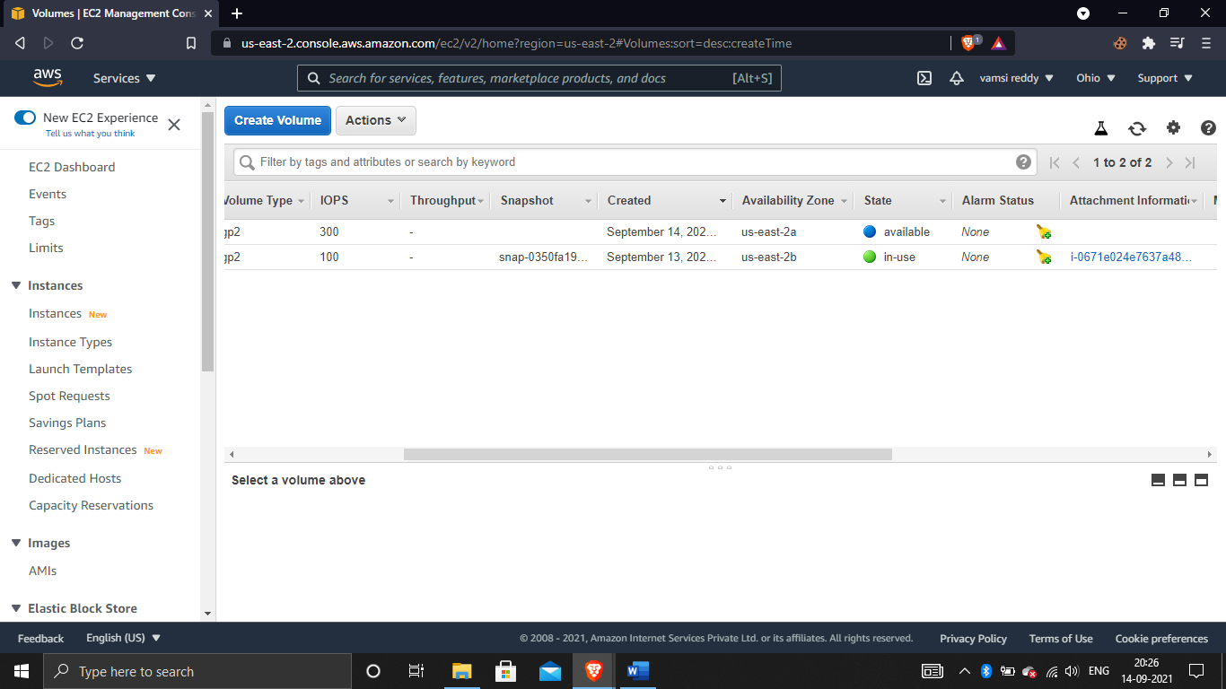

Here you need to choose the instance, which is running after completion click on attach

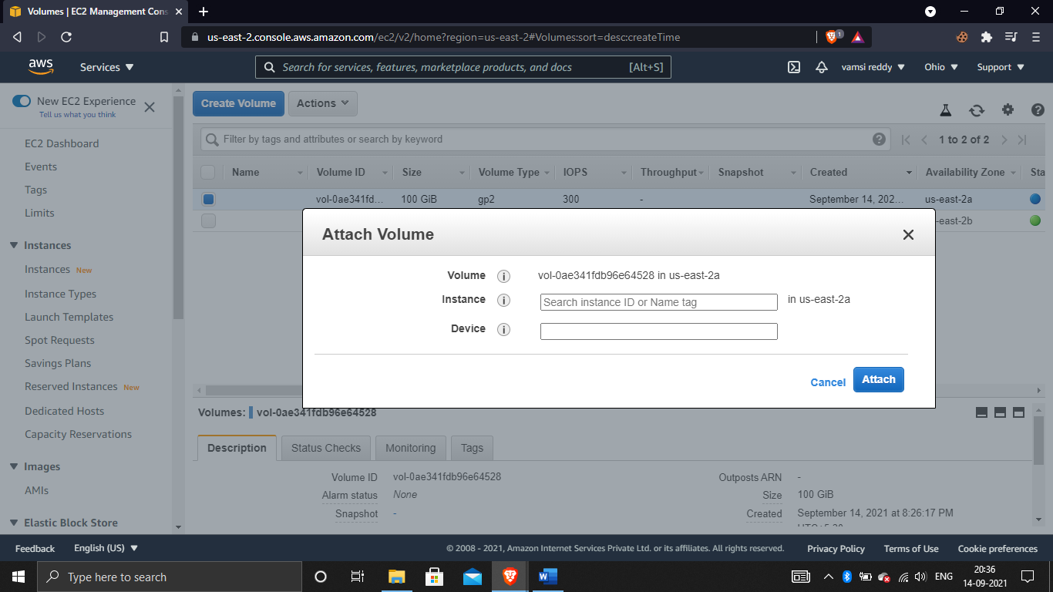

# ASSIGNMENT-4

Working with vpc:-

Create your vpc:-

There is a limit of maximum 5 vpc’s in a region.

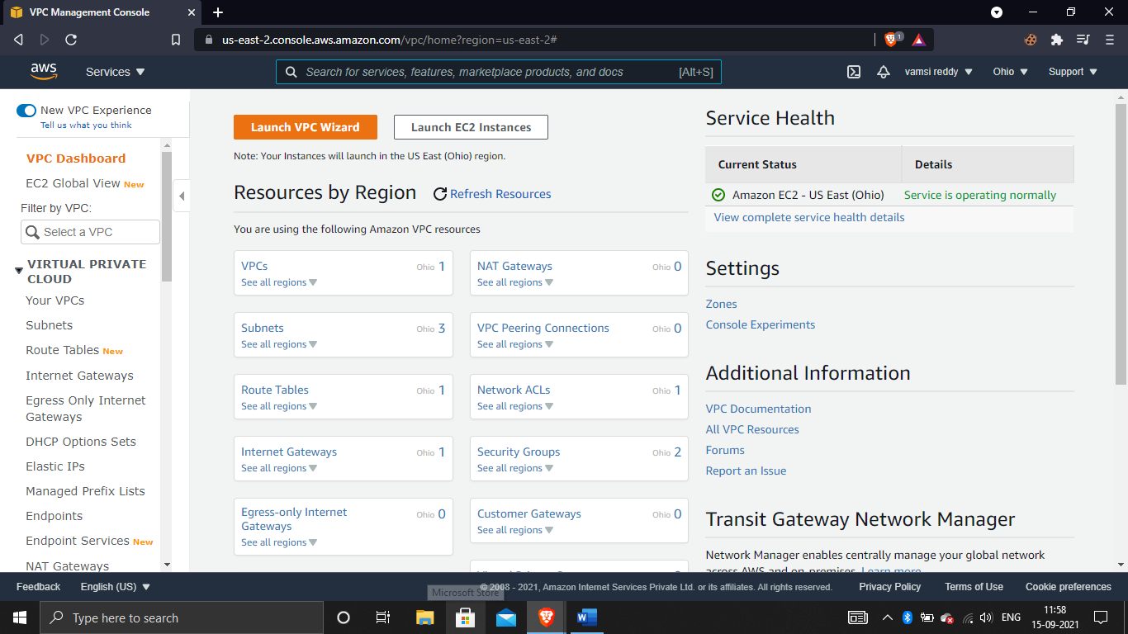

Now if you want to create vpc, click on your vpc’s and choose for the option create vpc and name the vpc and give ip address to ipv4 odr block and create it.

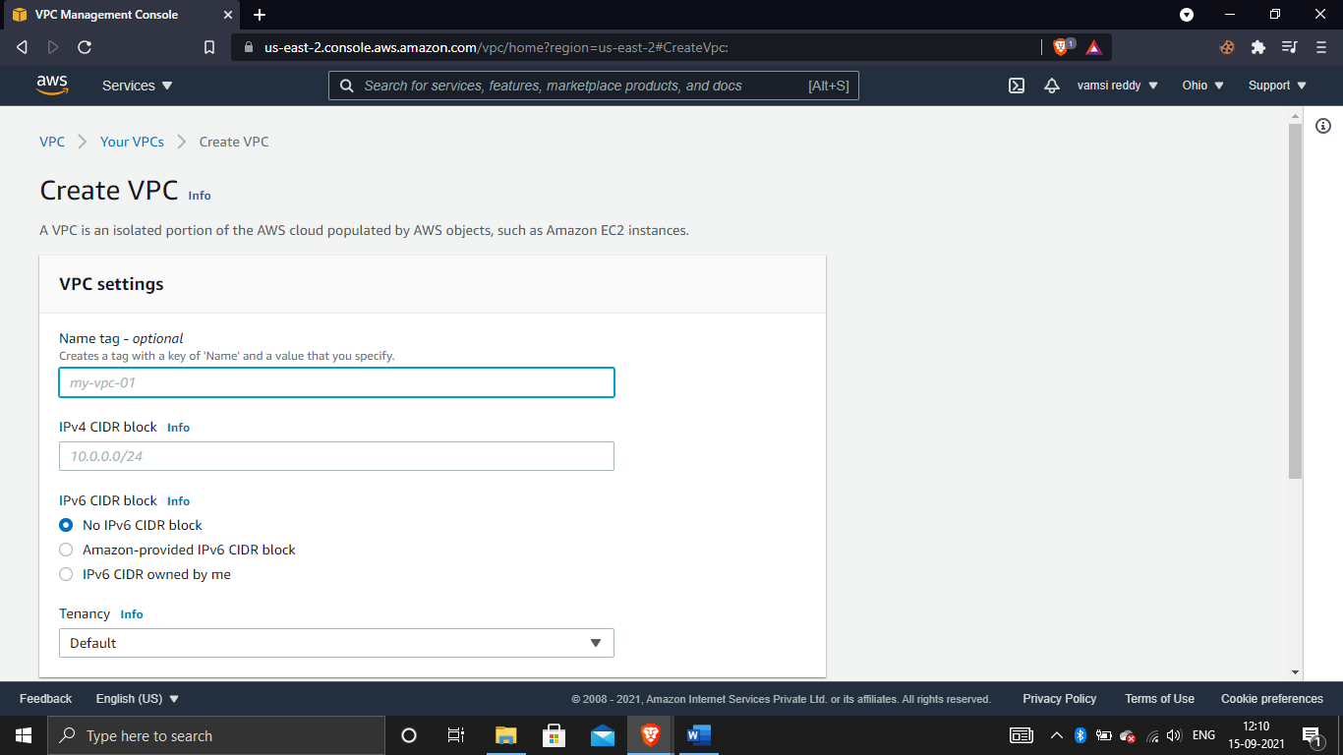

And now the vpc is created.

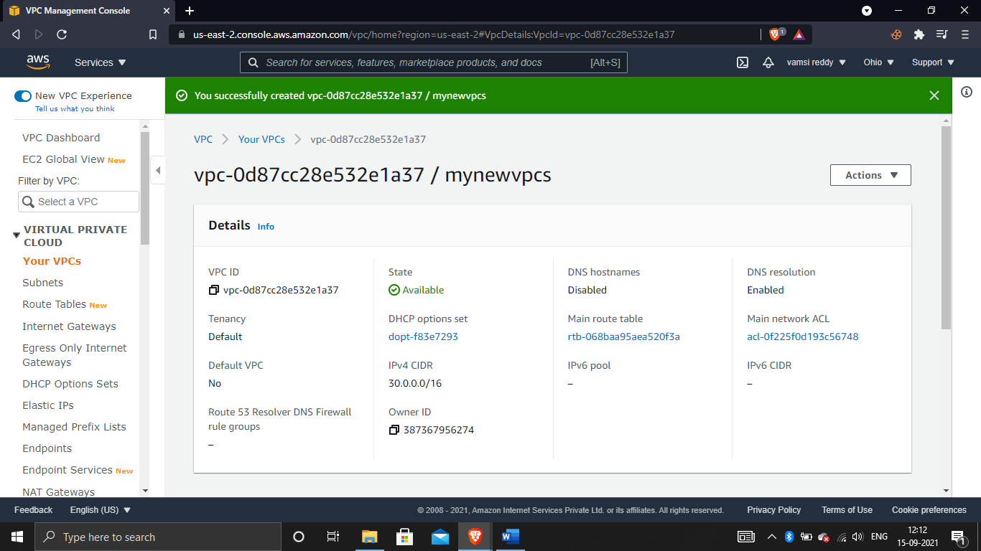

Create a internet gateway:-

To create a subnet click on subnet on dashboard and check for create option and click on it. Now give name to vpc id which u create in before now give some subnet value on IPv4 CIDR block.

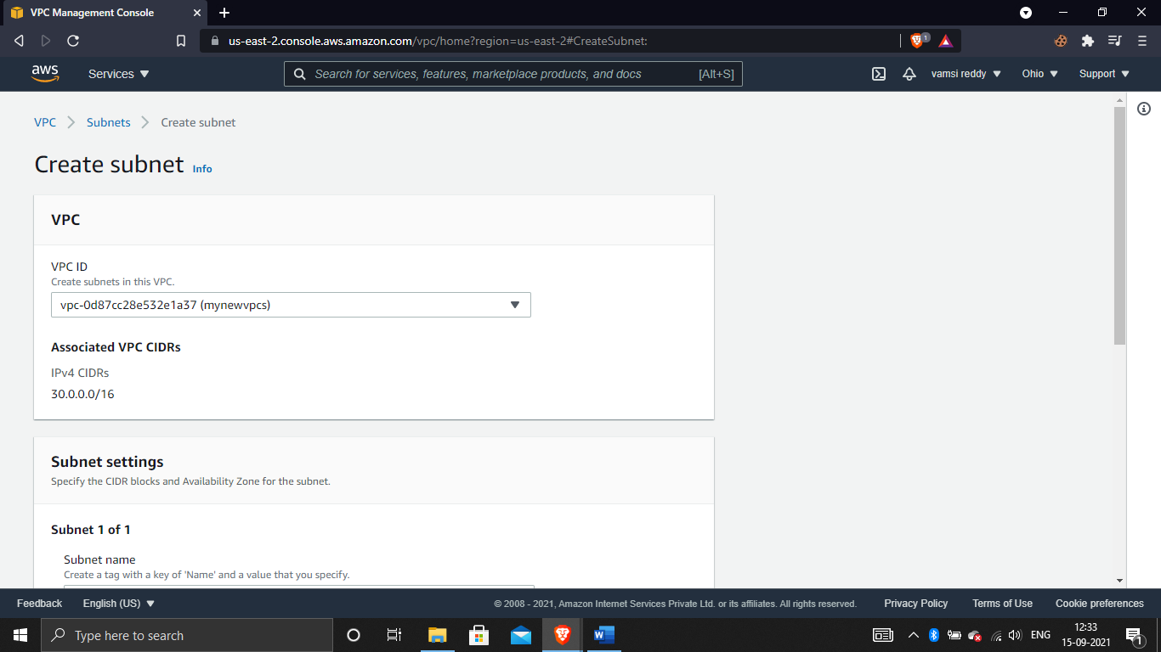

And now the subnet is also created.

Create a subnet-Enable auto assign public ip:-

Now select the subnet we have created and click on actions and click on modify auto-assign ip settings and Enable auto-assign public IPv4 address and save it.now the subnet is changed.

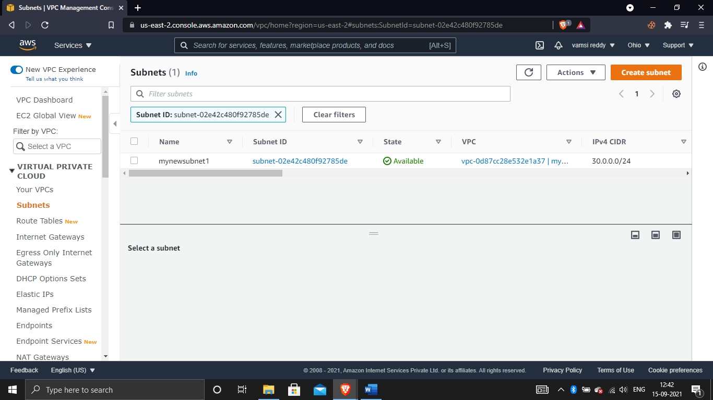

Create a route table make it the main route add a route table entry to IGW:-

Check for route tables option on dashboard click on it and create a route table.name Give a name for route table and select the default vpc and click on create route table.

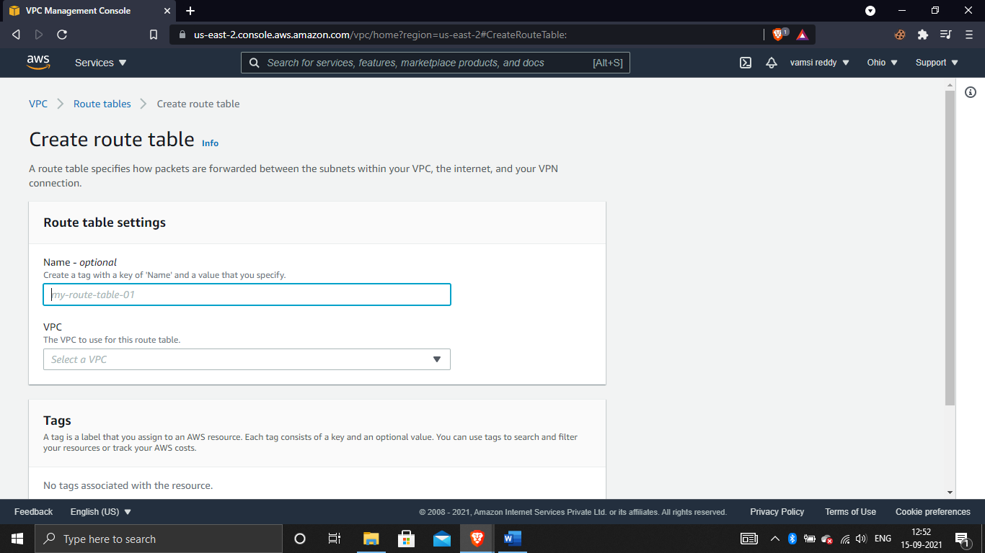

And the route table is created. now in the route table it shows the main is No, click on actions and set as main route table and confirm it to save it as main.

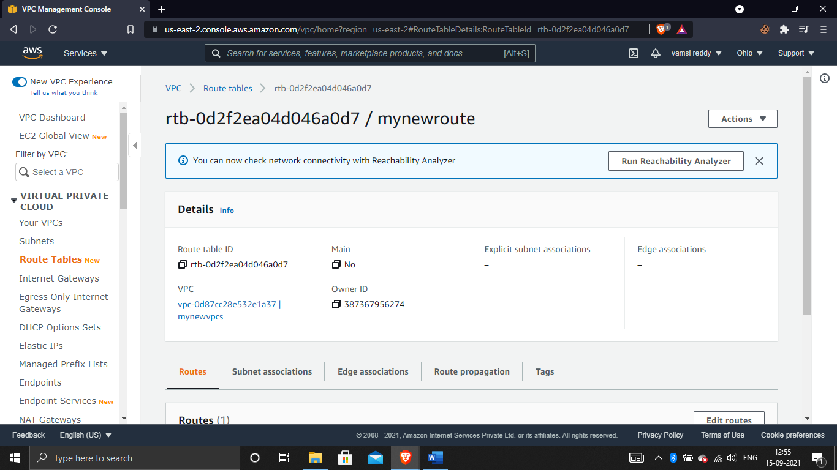

Launch a instance in custom vpc:-

Open EC2 and click on instances check for launch instances click on it and here change the network to what you have created and click on launch.this is the way you need to create network and add into the instances.

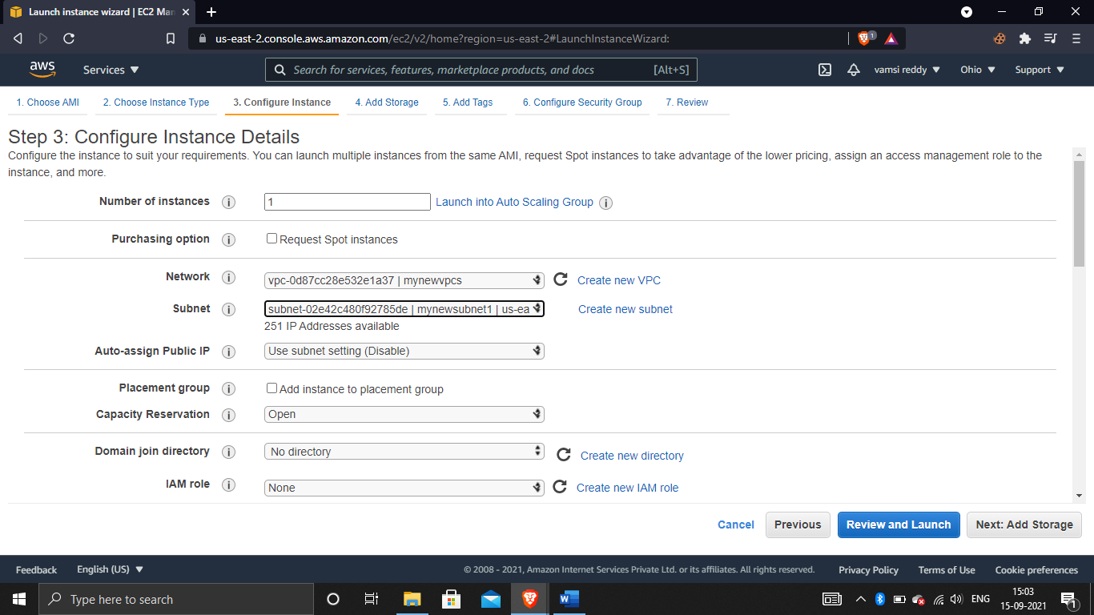

# ASSIGNMENT-5

Deploying a sample application on elastic beanstalk:-

Create an application:-

We need to create an web application so give a name to the application. And choose the platform what you want to create,select the application code and create the application.

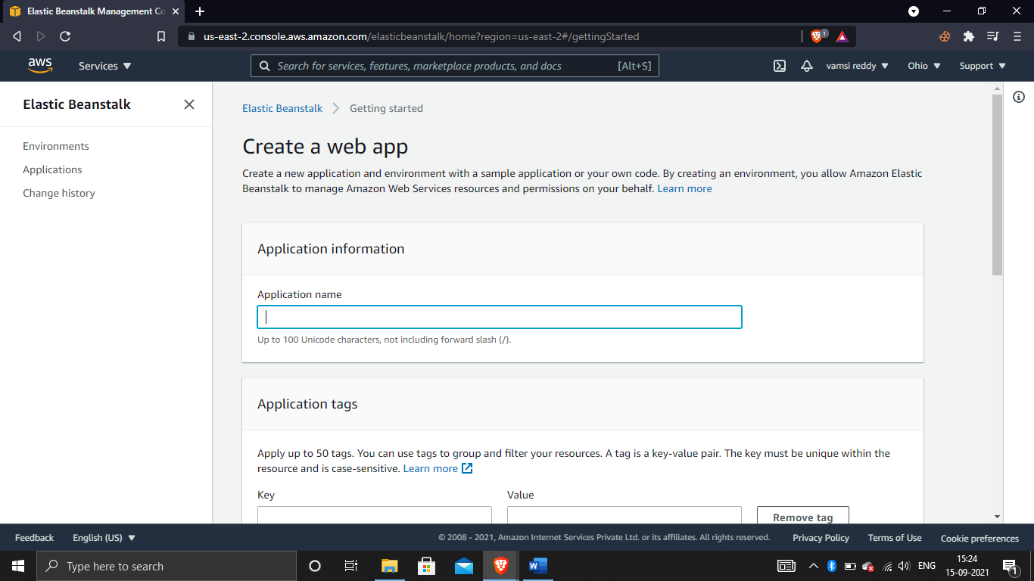

Launch the web page and verify:-

Now launch the application it takes some time to complete the process, after completion its shows like this which means our web application is created.